Session 6: Case Study Orientation
Business questions, dataset flow and expected outcomes

Task 1: Three business questions (Flipkart case study)
Using a Flipkart-style product dataset (product name, category, price, rating, stock), these three business questions can be answered:
- Which product categories (mobiles, laptops, fashion, etc.) have the highest number of products with good ratings, and which categories have the lowest?
- How does price relate to customer rating? Do costlier products actually get better ratings, or are cheaper products rated just as well?
- Which products are frequently out of stock? Which categories need better inventory planning to avoid losing sales?

Task 2: Flow diagram, raw data to insights
Dataset used: a sample Flipkart product CSV from Kaggle or data.gov.in. The diagram below shows how data moves through a typical analytics project.
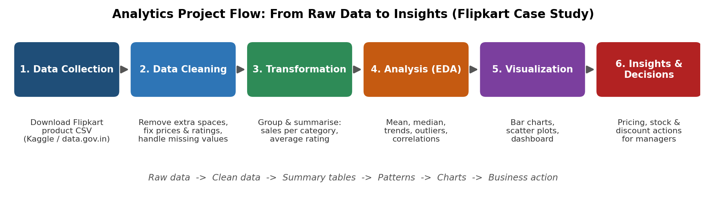
- Data Collection: download the raw CSV/Excel file.
- Data Cleaning: remove extra spaces, convert price and rating to numbers, handle missing values.
- Transformation: group and summarise the data, for example total products and average rating per category.
- Analysis (EDA): find averages, trends, relationships and outliers.
- Visualization: show the results in charts and dashboards.
- Insights and Decisions: share findings so managers can act.

Task 3: Expected outcomes (Flipkart case study)
A business would want the following results from analysing the Flipkart dataset:
Expected outcome | How it helps decision-making
Best-selling categories and products | Decide which products to stock more and promote on the home page.
Price vs rating vs discount patterns | Set smarter prices and discounts that raise sales without hurting profit.
Low-rated or slow-moving items | Remove or fix weak products, and raise quality concerns with sellers.
Stock-out and demand trends | Plan inventory ahead of sale seasons so popular items do not run out.

How this helps: These outcomes turn raw product data into clear facts. Managers can choose what to stock, how to price and discount, and which items to drop, so decisions are based on evidence instead of guesses. This improves sales, reduces losses from unsold or out-of-stock items, and keeps customers happier.

Task 4: Scenario for a food delivery app (Swiggy)
Scenario: I am a data analyst at Swiggy. Orders in Ahmedabad are getting delayed during dinner hours, and customers are giving low ratings and cancelling orders.
Business question: "Which areas and time slots in Ahmedabad have the longest delivery times, and what is causing the delay?"
Dataset needed: Order data with order ID, order time, restaurant ID, delivery area, preparation time, delivery partner ID, delivery time, distance, customer rating and cancellation status.
Expected outcome: A report and chart showing the slowest areas and hours, and whether the delay comes from slow restaurant preparation, too few delivery partners, or long distances. Swiggy can then add more delivery partners in busy slots, give incentives in problem areas, and work with slow restaurants to cut delays and cancellations.

